Ideation Phase
Empathize & Discover

Date | 06 April 2026
Team ID | 69bd2f9cc71a9ebd6a50e3b1
Project Name | Smart Library Workflow request in ServiceNow
Maximum Marks | 4 Marks

Empathy Map Canvas:
An empathy map is a simple and easy-to-understand visual tool that captures the behaviours, needs, and attitudes of users interacting with the library system.
In the Smart Library Request Workflow, the empathy map helps analyse how students and librarians experience the current manual process and what improvements are needed.
Example:
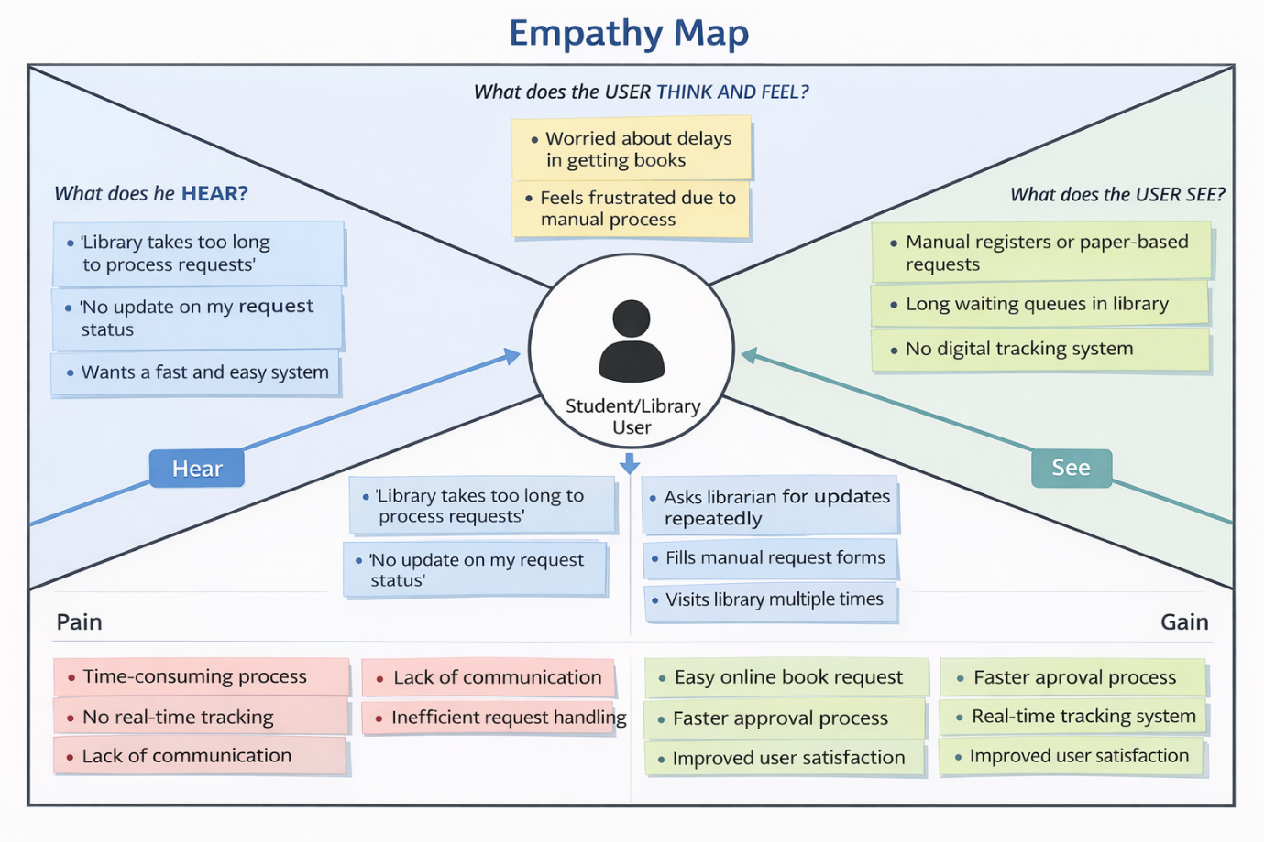

Reference: https://www.mural.co/templates/empathy-map-canvas

Example: Food Ordering & Delivery Application
